### Exploratory Data Analysis (EDA)

As part of the initial data exploration, we translated all column names from Hebrew to English to ensure consistent naming conventions and enable seamless analysis using Python tools. We then conducted an extensive EDA to understand the structure, quality, and behavior of the surgical data collected from Assuta Ramat HaHayal. The process began with data cleaning—handling missing values, converting date and time fields to datetime objects, and identifying duplicate or inconsistent records.

We created new datetime columns to reflect critical surgical milestones such as room entry, incision, closure, and exit. These were essential for calculating surgical durations and transition times between operations. Visualizations such as boxplots and histograms were used to analyze distributions of surgery durations, turnover times, and length of stay (LOS) per department and surgeon.

We also examined the timing and frequency of surgical activities across different days, seasons, and specialties to identify trends, peak loads, and underutilized time blocks. These insights guided the modeling efforts later in the project.

### Utilization Rate Calculation

To quantify operating room efficiency, we calculated the Utilization Rate (UR) for each operating room per day.

Where:

* Incision Time and Closure Time refer to the actual duration of surgery.
* Scheduled Block Time represents the surgeon’s allocated shift hours in the operating room.

The result reflects how much of the available OR time was actively used for surgeries, excluding prep or idle periods. High utilization indicates efficient scheduling, while values above 89% may suggest system overload. Our analysis aimed to keep utilization in the recommended 81–89% range.

This metric was used throughout the project to evaluate performance, identify inefficiencies, and support decision-making for future scheduling and resource allocation.

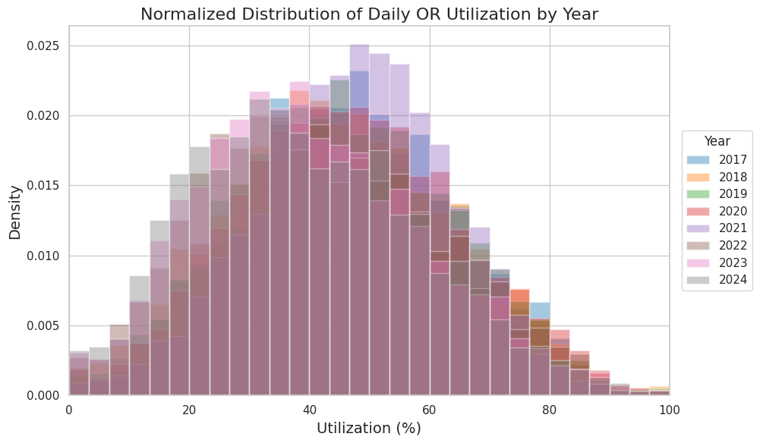

Figure 1. Normalized Distribution of Daily OR Utilization by Year (2017–2024)

The figure presents the normalized distribution of daily operating room (OR) utilization rates across the years 2017 to 2024. Across all years, the distributions follow a similar unimodal shape, with most days concentrated between 30% and 70% utilization, and relatively few days falling below 20% or exceeding 80%. This consistent pattern highlights that, under regular conditions, ORs at Assuta Ramat HaHayal typically function at about half of their full capacity.

Nonetheless, when the data is segmented into pre-pandemic, pandemic, and post-pandemic periods, distinct shifts in distribution patterns emerge:

1. Pre-COVID-19 Period (2017–2019): These years show well-defined peaks around 50–60% utilization, indicating stable schedules and predictable surgical workflows.
2. Pandemic Year (2020): The distribution for 2020 is notably flatter and shifts leftward, reflecting the substantial decrease and variability in daily utilization caused by widespread cancellations of elective procedures during the onset of the COVID-19 pandemic.
3. Recovery Phase (2021): Utilization begins to increase again, with the peak moving toward the 45–55% range. However, the distribution remains wider, suggesting greater variability and less predictability than in pre-pandemic years.
4. Post-Pandemic Stabilization (2022–2024): Utilization patterns in 2022 and 2023 return to levels similar to pre-pandemic years, with sharper peaks and reduced spread. Early data from 2024 appears to continue this trend of recovery and stabilization, albeit with minor residual fluctuations.

These findings emphasize both the resilience and adaptability of OR operations. Despite the severe disruptions of the pandemic, utilization patterns returned to a steady state within two to three years. This recovery reflects successful adaptation in surgical scheduling and resource allocation. Furthermore, the ability to maintain a consistent range of utilization in recent years suggests that operational efficiency has not only rebounded but is being sustained over time.

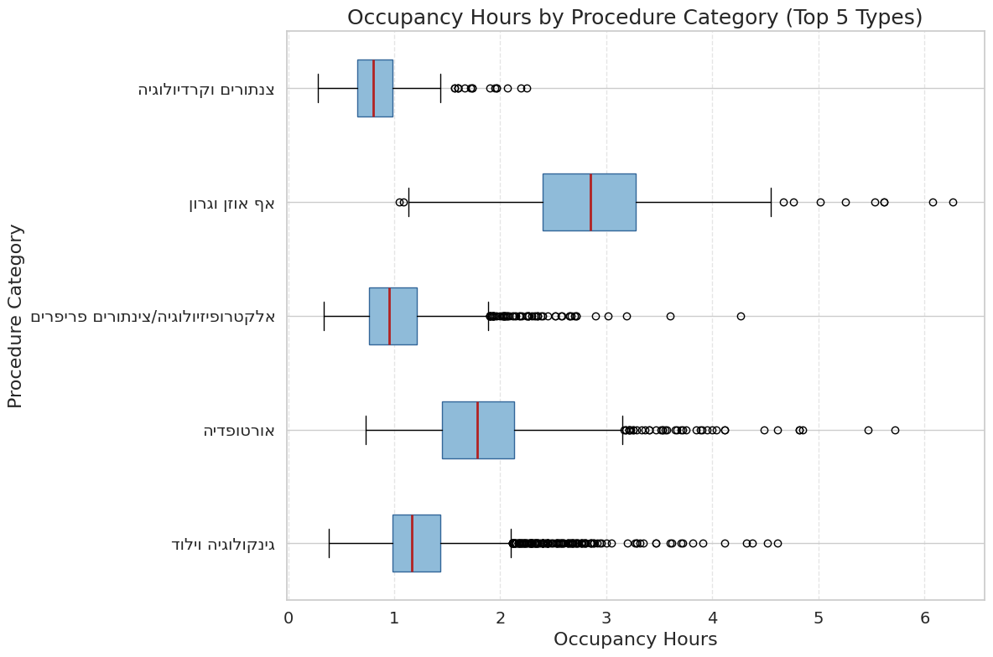Figure 2. Occupancy Hours by Procedure Category (Top 5 Types)

The boxplot visualizes the distribution of operating room occupancy hours across the five most common surgical categories at Assuta Ramat HaHayal. Clear differences emerge between specialties in terms of both typical procedure length and variability:

* Cardiology & Catheterizations (צנתורים וקרדיולוגיה): These procedures are short and highly consistent, with a median occupancy under 1 hour and a narrow interquartile range (IQR ≈ 0.6–1.0 hours). Few outliers are observed beyond 1.5 hours, making this category well-suited for flexible scheduling around longer cases.
* Electrophysiology / Peripheral Catheterizations (אלקטרופיזיולוגיה / צנתורים פריפריים): These cases are slightly longer (median ≈ 1.2 hours) but maintain a predictable profile with most durations under 2 hours. Their low variability (IQR ≈ 0.8–1.4 hours) allows for reliable time allocation.
* Gynecology & Obstetrics (גינקולוגיה וילוד): These procedures have a median occupancy of ~1.3 hours and moderate variability (IQR ≈ 1.0–1.6 hours). While most cases fall under 2 hours, some outliers exceed 4–5 hours, indicating a need for occasional buffer time in scheduling.
* Orthopedics (אורטופדיה): Orthopedic surgeries exhibit substantially longer durations (median ≈ 2.6 hours) and high variability (IQR ≈ 1.7–3.2 hours), with numerous high-end outliers up to 4.5 hours or more. This makes accurate time estimation more difficult and requires more flexible scheduling.
* Ear, Nose & Throat (אף אוזן וגרון): ENT cases are the most time-consuming overall (median ≈ 2.9 hours), with the widest variability (IQR ≈ 2.4–3.5 hours) and occasional extreme outliers extending up to 6 hours. These reflect complex or multi-stage procedures that can significantly exceed average durations.

Scheduling Implications:

1. Use predictable short-duration specialties (Cardiology, Electrophysiology) to fill idle blocks and maintain utilization efficiency.
2. Assign extended blocks and larger buffers for high-variability categories like Orthopedics and ENT to reduce the risk of cascading delays.
3. Schedule moderate buffers for Gynecology & Obstetrics to account for occasional extended cases while maintaining throughput.

Adapting block durations and buffer strategies to the statistical characteristics of each surgical category can significantly enhance overall operating room efficiency, reduce overruns, and improve on-time starts.

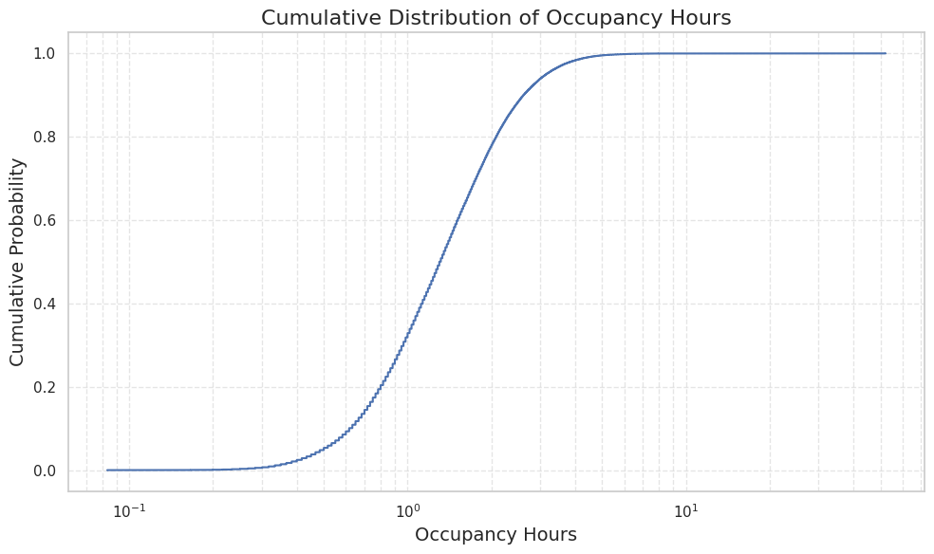Figure 3. Cumulative Distribution of Occupancy Hours

This cumulative distribution plot, presented on a logarithmic x-axis, illustrates the empirical cumulative distribution function (CDF) of operating room (OR) occupancy times. The distribution exhibits a clear "bulk plus long tail" structure, which has direct implications for surgical scheduling:

* Fast-track procedures (bottom 25%) are completed within 1 hour, capturing mostly cardiac catheterizations and other short-duration cases.
* The median occupancy time is approximately 2 hours, meaning half of all procedures conclude within that timeframe.
* 75% of cases are completed by around 3.8 hours, reflecting the duration of typical procedures such as gynecological surgeries and peripheral catheterizations.
* 90% of cases finish within 5 hours, and 95% within 8 hours, suggesting that an 8-hour OR block can accommodate the vast majority of procedures.
* The final 5%, and particularly the top 1% of procedures exceeding 10 hours, represent a long-tail segment likely consisting of complex or multi-stage operations—commonly found in orthopedics and ENT.

Implications for Operating Room Management:

1. Optimizing Block Lengths:  
   * Standard 2–4 hour blocks are well-suited for accommodating most procedures (50–75%).
   * A full 8-hour block is sufficient for 95% of cases and can serve as the upper bound for daily scheduling.
2. Buffer and Contingency Planning:  
   * Given the heavy right tail, it is advisable to allocate dedicated buffer time or overrun slots to absorb the small percentage of extended-duration cases and prevent ripple effects throughout the schedule.
3. Hybrid Scheduling Strategies:  
   * For predictable, short-duration specialties (e.g., cardiology), deploy short blocks with minimal buffer.
   * For high-variance specialties (e.g., orthopedics, ENT), consider longer reserved blocks or isolated scheduling days to accommodate variability while maximizing overall OR utilization.

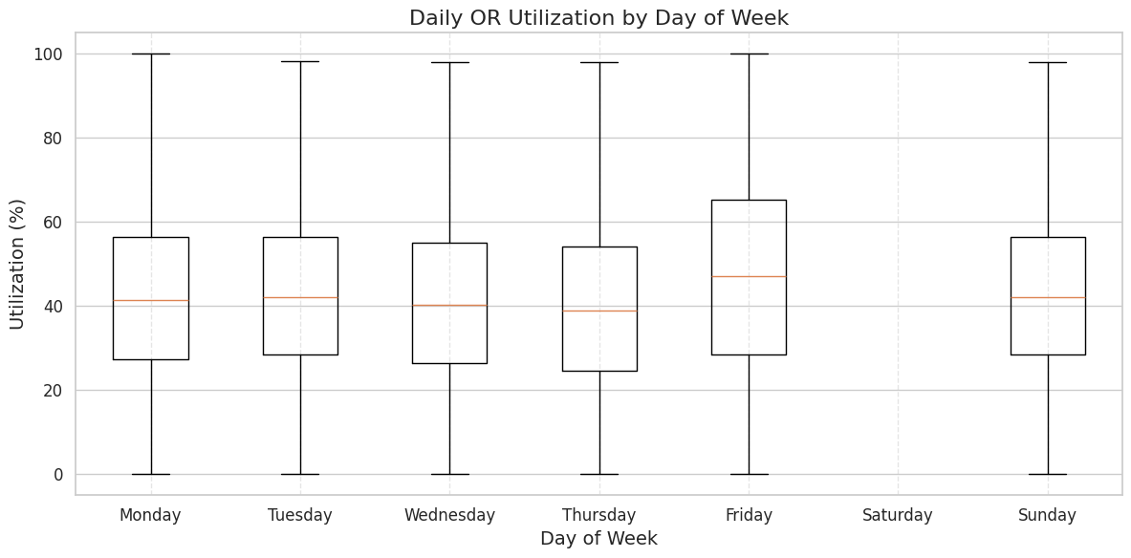

Figure 4. Daily OR Utilization by Day of Week

This boxplot illustrates operating room (OR) utilization rates by day of the week, revealing distinct weekly trends in surgical activity:

* Sunday to Thursday (standard workdays):  
   Utilization is relatively stable, with median values between 39% and 42%. The interquartile range (IQR ≈ 25%–55%) reflects moderate variability, consistent with routine elective scheduling and a steady flow of cases. Outliers are rare, indicating reliable planning and execution.
* Friday:  
   Friday shows a noticeable increase in median utilization to approximately 47%, the highest among weekdays. The wider IQR (~28%–65%) and frequent values approaching 100% suggest this day often absorbs spillover, add-on, or urgent cases, resulting in higher volatility.
* Saturday:  
   Utilization drops sharply, with most values at or near 0% and a negligible median. This reflects the near-complete shutdown of elective activity on Saturdays, with only emergency and urgent surgeries being performed.

Scheduling Implications:

1. Maintain regular elective schedules from Sunday through Thursday, aligned with predictable demand patterns.
2. Allocate extra buffer capacity on Fridays to handle late-week add-ons and prevent schedule overruns.
3. Designate Saturdays for emergencies only, using minimal staffing and block allocation to preserve readiness without incurring unnecessary idle time.

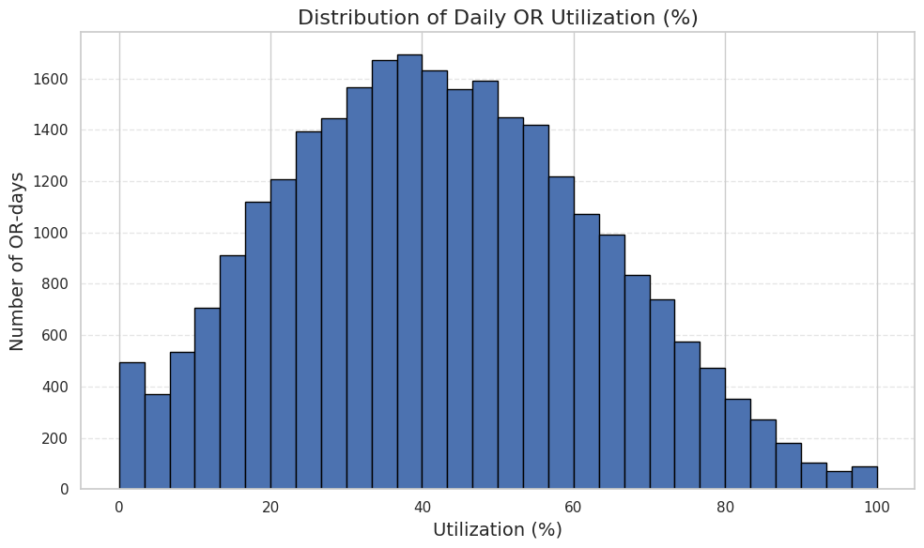

### Figure 5. Operating Room Utilization: Trends and Scheduling Insights

Analysis of daily operating room (OR) utilization across ~27,000 OR-days at Assuta Ramat HaHayal reveals a consistent unimodal distribution, with the majority of days falling between 20% and 60% utilization. The most common utilization range is 35–40%, suggesting that under typical conditions, surgical rooms operate at roughly one-third of their theoretical capacity. Only a small portion of days exceed 80% utilization, and fully booked days above 95% are extremely rare, comprising less than 0.3% of cases. Conversely, days with less than 10% utilization—often weekends, holidays, or emergency-only sessions—account for about 10% of the total.

When broken down by year, a broader trend becomes apparent. Between 2017 and 2019, utilization was relatively stable with narrow, centered distributions around 50–60%. The onset of the COVID-19 pandemic in 2020 triggered a sharp leftward shift in the distribution, reflecting reduced surgical activity and increased variability. Recovery began in 2021, though with continued spread in values, while by 2022–2024 the distributions closely returned to pre-pandemic patterns. This trajectory highlights the resilience of OR operations and the ability to stabilize utilization after disruption.

A weekly analysis reveals a strong rhythm in utilization by day of week. From Sunday through Thursday, median daily utilization remains stable around 39–42%, with moderate variability and few extreme outliers. Fridays show a marked increase, with median utilization rising to 47% and a broader spread that includes frequent days at full capacity. This pattern suggests that Friday often functions as a buffer for add-on cases and schedule spillovers. Saturdays, in contrast, exhibit minimal utilization—typically below 5%—as elective surgeries are suspended, and only urgent or emergency cases proceed.

A cumulative distribution of occupancy hours further supports these observations. About 25% of all procedures occupy less than 1 hour, and 50% finish within 2 hours. By the 75th percentile, procedures tend to complete within 3.8 hours, and 90% remain under 5 hours. A full 8-hour block accommodates approximately 95% of cases, while only a small minority (≈5%) extend beyond that. The heavy right tail—especially the 1% of procedures lasting over 10 hours—mainly reflects complex or combined surgeries, typically in orthopedics or ENT.

When comparing procedure categories, clear differences in expected occupancy time emerge. Cardiology and catheterizations are the shortest and most consistent, rarely exceeding 1 hour, making them highly suitable for flexible scheduling. Electrophysiology and gynecology procedures tend to be mid-length (1.2–1.5 hours), with low to moderate variability. Orthopedic and ENT surgeries, however, are longer and far more variable, often requiring dedicated blocks and buffer time. ENT procedures, in particular, show the widest spread, with some cases extending up to 6 hours.

Together, these findings support the development of a differentiated scheduling strategy. Short-duration, predictable specialties should be used to fill underutilized slots and smooth out daily fluctuations. High-variance categories should be assigned longer, flexible blocks with built-in overrun capacity. Block lengths should generally center around 2–4 hours to capture the majority of cases, while a limited number of 8-hour slots can accommodate complex procedures. Finally, adopting dynamic scheduling tools such as late add-ons, flexible start times, and tailored buffer policies can help reduce idle time and increase OR throughput without expanding physical resources.

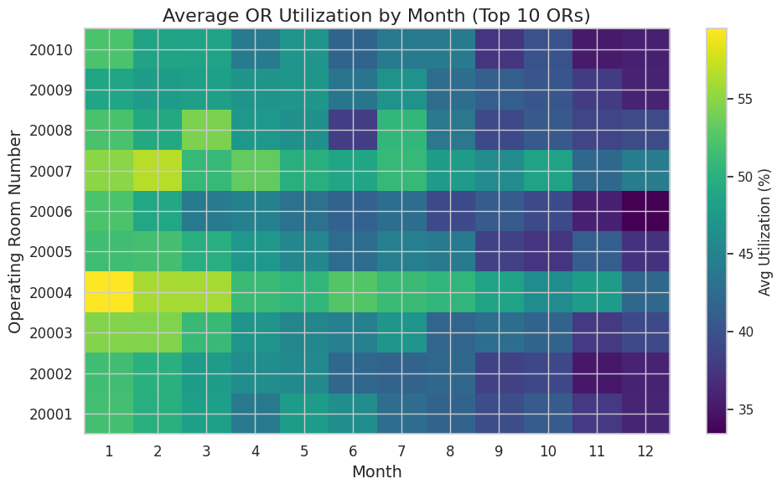

Figure 6. presents a monthly heatmap of average utilization across the ten busiest operating rooms (ORs) at Assuta Ramat HaHayal. The visualization highlights a strong seasonal rhythm alongside distinct room-specific usage patterns, offering valuable insights for operational planning.

A clear annual cycle emerges across all rooms. Utilization peaks during late winter and early spring (January to March), with top-performing ORs—most notably OR 20004—reaching average utilization rates of 60% or higher in January. This period likely reflects full resumption of elective procedures after the holiday season and a strategic push to reduce patient backlogs.

As the year progresses, a gradual decline occurs between April and June, with most rooms experiencing a 5–10 percentage point drop in average utilization. This decline reaches a low point around June, potentially influenced by seasonal decreases in surgical demand or resource allocation. A modest rebound follows in July and August, suggesting partial recovery in elective scheduling during the summer months. Utilization levels during this phase typically stabilize between 50–55% in most rooms.

Entering the fall, September and October exhibit renewed activity, with utilization climbing again toward 55%—likely tied to the restart of full surgical programs post-summer. The year concludes with a sharp downturn in November and December, where utilization falls to its lowest levels across all rooms, commonly below 40%. This decline coincides with holidays and reduced elective scheduling.

Room-level patterns further reveal operational strategies. OR 20004 and OR 20007 consistently lead in performance, maintaining high utilization throughout the year and demonstrating minimal drop-off during seasonal troughs. In contrast, OR 20006 and OR 20010 exhibit pronounced variability, with steep swings exceeding 20 percentage points between peak and low months, hinting at shifts in assignment, reduced use during holidays, or planned maintenance. Meanwhile, rooms like 20003, 20005, and 20009 maintain relatively stable usage year-round, with variations limited to within 15 points—making them ideal candidates for rolling or flexible elective block allocations.

These findings carry several operational implications. Periods of reduced demand, especially December and June, represent optimal windows for scheduled maintenance, staff vacations, or training programs. In contrast, peak winter months demand enhanced staffing and full elective capacity, particularly in high-performing rooms such as OR 20004 and 20007. During transitional periods like midsummer, focusing elective activity on more stable rooms (e.g., OR 20003 or OR 20005) may help sustain throughput while allowing others to flex based on real-time demand.

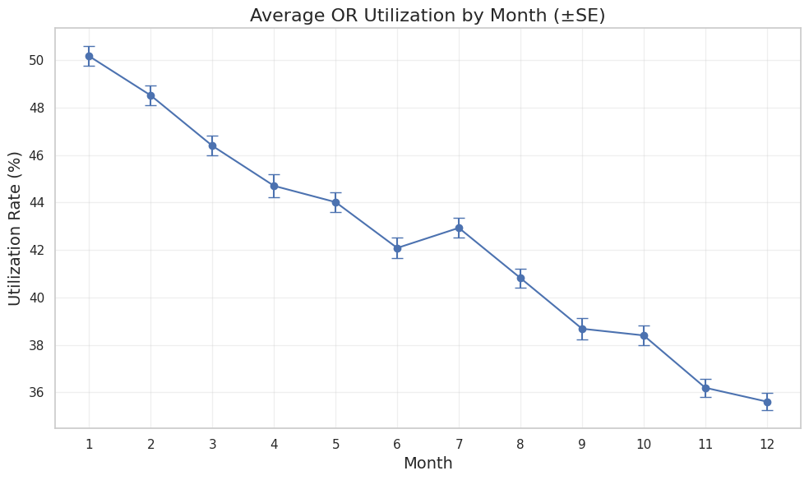

Figure 8. displays the average monthly utilization of operating rooms (ORs) throughout the calendar year, including standard error bars to indicate statistical variability. The line plot reveals a clear and consistent seasonal decline in utilization, with minimal variation across years. This pattern reinforces findings from room-level analyses and highlights systematic shifts in hospital activity over the course of the year.

January marks the peak of annual utilization, with an average of approximately 50.2% (±0.5). This high point coincides with the restart of full elective surgical programs following the year-end holiday slowdown. From February to June, there is a steady downward trend, with average utilization gradually falling from 48.4% to 42.1%, likely reflecting tapering winter case loads and gradual exhaustion of early-year scheduling momentum.

Interestingly, July shows a slight uptick, climbing back to 42.8% (±0.4). This modest rebound may reflect efforts to compensate for mid-year cancellations or to prepare for planned slowdowns during summer holidays. However, this is short-lived, as August through October resume the decline, descending from 40.7% to 38.4%. This period likely reflects a combination of vacation-related scheduling gaps and limited resource availability.

The lowest utilization rates are observed in November and December, averaging 36.2% (±0.3) and 35.6% (±0.3) respectively. These troughs are strongly aligned with year-end holiday reductions in elective activity and scheduled maintenance periods.

Importantly, the standard errors across all months remain small (0.2–0.5 percentage points), underscoring the statistical robustness of these monthly differences and validating the reliability of the trend.

Taken together, this analysis highlights a predictable and actionable seasonal cycle. Peak months (January–March) should be prioritized for maximizing elective surgery throughput, while December and June are particularly well-suited for planned staff leave, training sessions, or room maintenance, given the consistent drop in utilization.

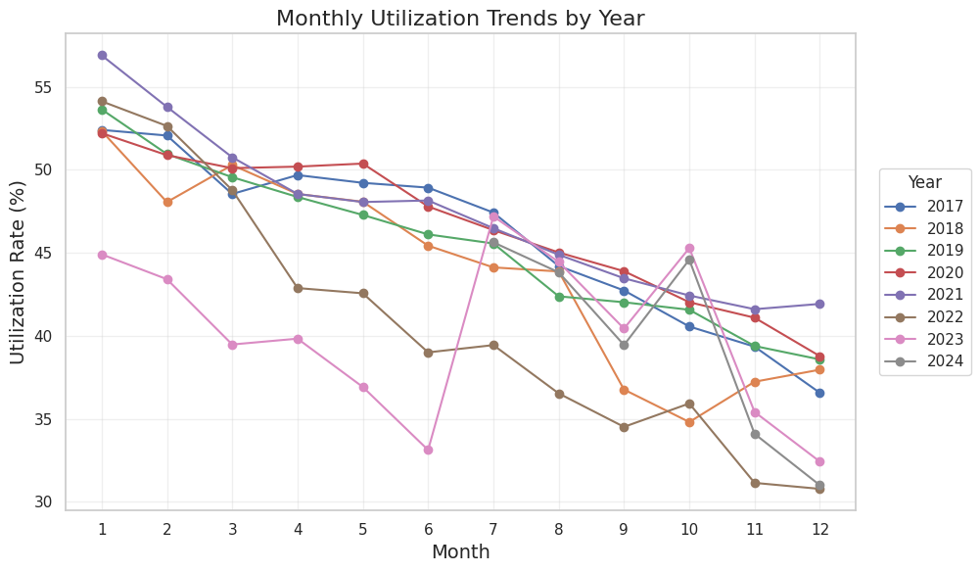

Figure 9 illustrates the monthly trends in average operating room (OR) utilization across the years 2017–2024, enabling a direct comparison of seasonal cycles, pandemic effects, and emerging recovery signals. Despite the variation in absolute levels, the general seasonal structure is remarkably consistent across the timeline, with three key themes emerging from the data.

First, a recurring annual pattern is evident in nearly every year. Utilization peaks in the winter months (January–March), with pre-COVID years (2017–2019) typically starting above 52%, and declining slightly by March. This is followed by a steady decrease through spring and early summer (April–June), with typical values falling to around 46–48%. Some years, such as 2017, 2019, and 2021, show a modest rebound in July, suggesting compensatory scheduling before the traditional summer slowdown. In the latter part of the year, utilization plateaus in early fall before drifting downward again into a consistent year-end trough (November–December), where values commonly fall to 36–39%—driven by reduced elective activity and increased maintenance operations.

Second, the dataset captures the impact of the COVID-19 pandemic and subsequent recovery phases. In 2020, surprisingly, the overall pattern remains close to historical norms, with only a modest summer dip, perhaps reflecting a focused effort to maintain elective surgeries despite global disruptions. 2021 stands out with the highest January utilization (~57%), possibly a result of backlog clearance from 2020 delays, though this momentum tapers off by year-end. The most anomalous trend appears in 2022, which starts relatively strong but experiences a sharp spring collapse, followed by continued decline—bottoming out at ~31% in December. This may reflect renewed COVID waves, operational fatigue, or logistical constraints. 2023 remains below historical norms throughout, with utilization stagnating in the high 30% to low 40% range, though a temporary uptick between July and October hints at partial recovery before another year-end dip.

Finally, early 2024 data (January–June) suggest a positive shift. Utilization begins around 44%, climbs steadily to ~49% in March–April, and stabilizes near 45% by June. While the second half of 2024 remains to be observed, this upward trajectory implies a return to pre-pandemic operational patterns and improved scheduling capacity.

These year-by-year insights support several operational strategies. Block planning should continue to account for a dual-phase year—with full-capacity blocks in winter and reduced activity in late-year months. February and March appear to be crucial for backlog management and may require surge staffing, whereas December and June provide logical targets for planned maintenance or scaled-down operations. Moreover, continued monitoring through the remainder of 2024 will be essential to assess whether OR utilization has truly stabilized, or whether long-term adjustments in scheduling, staffing, or resource allocation will be required in the post-pandemic landscape.

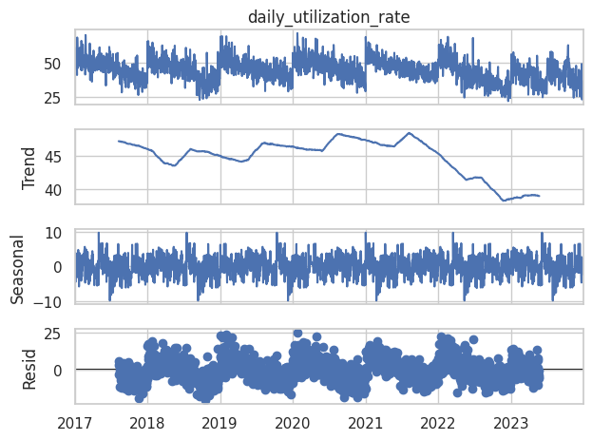

Figure 10. presents a classical time-series decomposition of daily operating room (OR) utilization at Assuta Ramat HaHayal, spanning from early 2017 through mid-2023. The decomposition separates the original signal into three components: long-term trend, seasonal effects, and residual (random) variation. It is important to note that this analysis covers only full calendar cycles, and thus data from 2024 were excluded, as the decomposition method (seasonal_decompose) requires complete annual periods for accurate separation of trend and seasonality.

The trend component shows a clear and gradual downward shift in overall utilization over the 6.5-year period. In early 2017, average daily utilization hovered around 47–48%, but by late 2022 and into 2023 it declined steadily to approximately 39–40%. While the general trajectory is downward, several mid-year recoveries are visible—most notably in 2018, 2019, and early 2021—reflecting temporary rebounds or post-holiday case surges. These were often followed by steeper drops, especially during or after COVID-19 waves and in periods of capacity adjustment or recovery fatigue.

Overlaying this long-term drift is a consistent seasonal pattern, with strong, repeating fluctuations that align with the calendar year. Utilization peaks reliably in the late winter and early spring months (January to March), where deviations from the trend line reach approximately +6 to +8 percentage points. Conversely, usage consistently dips in November and December, reflecting a seasonal trough of –6 to –8 percentage points relative to the baseline. This seasonal effect mirrors findings seen in prior figures (e.g., the monthly heatmap and average seasonal curve), reinforcing the influence of predictable hospital calendar dynamics, including elective case surges after holidays and end-of-year slowdowns.

The residual component, representing day-to-day deviations not explained by the trend or seasonal model, appears mostly random and without persistent autocorrelation. While there are occasional spikes—corresponding to extreme under- or over-utilization days, such as full OR schedules or emergency-only weekends—these are exceptions rather than systematic features.

Overall, this decomposition highlights a few actionable insights. The long-term decline in utilization should prompt further examination of structural changes, whether they involve surgical case mix, block allocation strategies, or broader shifts in hospital operations. The stable annual cycle underscores the need to proactively align resources with predictable seasonal peaks and troughs—for instance, ramping up elective capacity and staffing in February–March, and planning maintenance or staff leave in November–December. Finally, the lack of residual structure suggests that most remaining fluctuations are best addressed through real-time responsiveness, such as short-notice scheduling, rather than through static long-term forecasts.

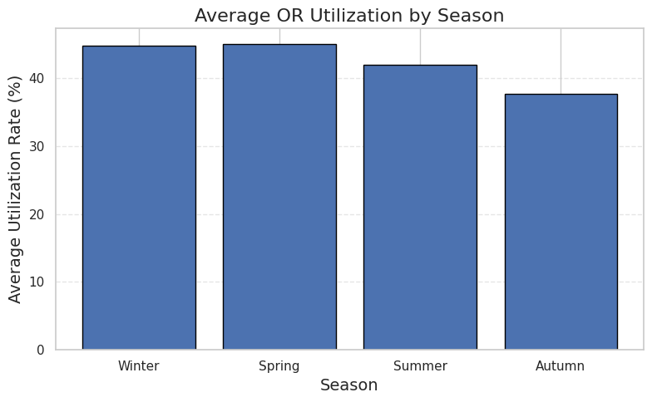

Figure 11 displays the average operating room (OR) utilization by meteorological season, highlighting a well-defined annual cycle in surgical activity. The data confirm that utilization is not uniform throughout the year, but instead follows a predictable, seasonally driven pattern that reflects institutional scheduling practices, patient demand, and broader calendar influences.

Utilization reaches its highest levels in spring (March–May), averaging approximately 45.2%. This period typically reflects the sustained momentum of elective scheduling following the early-year surge, offering a window of operational stability before the summer decline. Winter (December–February) follows closely behind at 44.6%, driven largely by backlog clearance after holiday slowdowns, especially in January and February. These two seasons together represent the periods of peak demand, with average utilization exceeding 44%, and are therefore critical for capacity optimization.

In contrast, summer months (June–August) show a modest decline in activity, with average utilization dropping to ~42.0%. This reduction is likely the result of scheduled vacations among both staff and patients, as well as a lighter elective case load. Autumn (September–November) marks the lowest point in the annual cycle, with average utilization falling to ~37.5%—approximately 7 percentage points below winter levels. This drop corresponds with year-end scheduling constraints, public holidays, and planned maintenance activities, which are known to reduce elective throughput during this time.

These seasonal dynamics support a number of practical planning strategies. High-demand periods—particularly spring and late winter—should be prioritized for full-capacity block assignments, including longer elective lists and expanded staffing where possible. Summer scheduling can be made more efficient by favoring short-case specialties or part-day block structures to match fluctuating demand without overcommitting resources. The autumn trough presents an ideal window for maintenance, training, or staff leave, as the operational impact on elective surgery is minimized. Finally, by implementing dynamic block reassignment policies—for example, rebalancing OR allocations from autumn into spring—institutions can more evenly distribute workloads and improve overall annual utilization efficiency.

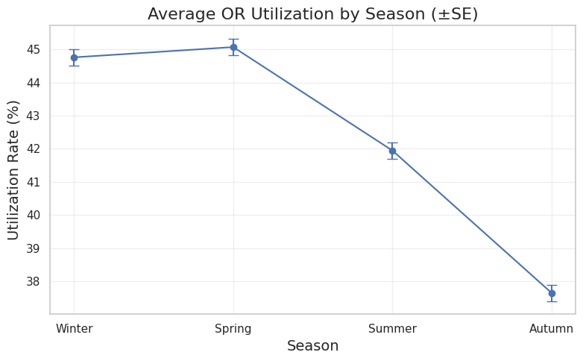

Figure 12. illustrates the average seasonal utilization of operating rooms (ORs), presented with standard error bars to indicate statistical precision around each estimate. The results reveal a clear and consistent seasonal pattern, with significant differences in utilization levels between seasons.

Utilization reaches its peak during the spring months (March–May), with an average rate of 45.1% ± 0.3. Winter (December–February) follows closely at 44.7% ± 0.2, indicating that the post-holiday surge and clearance of elective case backlogs result in a comparable workload to the stable scheduling observed in spring. These two seasons represent the operational high point of the year, where demand consistently exceeds 44%, and elective capacity should be maximized.

By contrast, summer (June–August) shows a clear decline in utilization, dropping to 42.1% ± 0.3, approximately 3 percentage points below winter. This likely reflects reduced case volumes due to scheduled leave, family holidays, and lower patient demand. The lowest average utilization is observed in autumn (September–November), with a marked decline to 37.6% ± 0.4. This 7-percentage-point drop relative to winter confirms that autumn remains the period of least surgical activity—driven by holiday-related scheduling limitations and end-of-year operational planning such as room maintenance and staff training.

The narrow standard errors (ranging from ±0.2 to ±0.4) highlight that these differences are statistically robust, not the result of random variation. The sharp and consistent gap between autumn and the rest of the year, in particular, underscores the importance of aligning resource allocation strategies with this seasonal cycle.

In practical terms, this analysis supports a seasonally adaptive approach to elective block planning. Full block allocation and increased staffing should be concentrated in late winter and spring, when demand is highest and stable. Conversely, autumn offers the optimal window for system-level interventions such as preventive maintenance, administrative catch-up, or planned workforce rotation, given its consistently reduced load and lower opportunity cost for downtime.

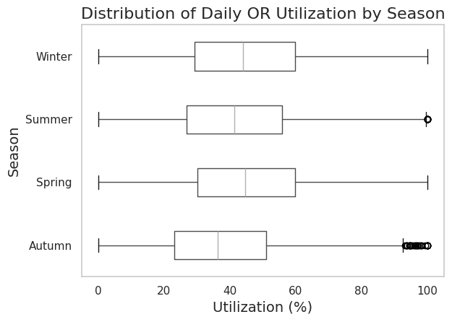

Figure 13. presents the distribution of daily operating room (OR) utilization by season, highlighting both the central tendency and variability in usage throughout the year. Unlike previous figures that focused on seasonal averages, this boxplot reveals the spread and skewness of utilization patterns within each season.

Across all seasons, the median daily utilization remains centered around 40–45%, consistent with earlier seasonal averages. However, the shape of each distribution reveals important differences in operational behavior. Spring and winter display the widest upper tails, with daily utilization values frequently exceeding 70%, and in some cases approaching 100%, particularly in winter. These occasional high-utilization days suggest periods of intense workload, likely driven by post-holiday backlog clearance (in winter) or concentrated elective scheduling (in spring).

Summer shows a similar central range but with greater variability toward the upper end, including visible outliers—days that pushed ORs to near or full capacity. This pattern may reflect unpredictable additions, such as urgent summer cases or last-minute scheduling changes to compensate for staffing shortages.

Autumn, in contrast, exhibits the lowest median and the most compressed upper range, with very few days exceeding 70% utilization. Notably, it also displays a cluster of high-end outliers near 100%, suggesting that although overall demand is lower during this season, a small number of days still experience full OR occupancy—perhaps due to rescheduling of delayed procedures or emergency accumulation prior to holiday closures.

What stands out across all seasons is the broad interquartile range (IQR)—a span from approximately 30% to 60% in every season—indicating that daily variability is substantial and persistent. While averages provide guidance for general planning, this distributional perspective emphasizes the need for day-level flexibility in resource allocation, regardless of season.

From a planning perspective, these findings reinforce the importance of buffer design and real-time scheduling tools. Even in low-demand periods like autumn, the presence of high-utilization outliers underscores the risk of overloading on select days if no surge capacity exists. Conversely, the presence of underutilized days in every season (including spring) suggests ongoing opportunities to optimize scheduling and consolidate block usage.

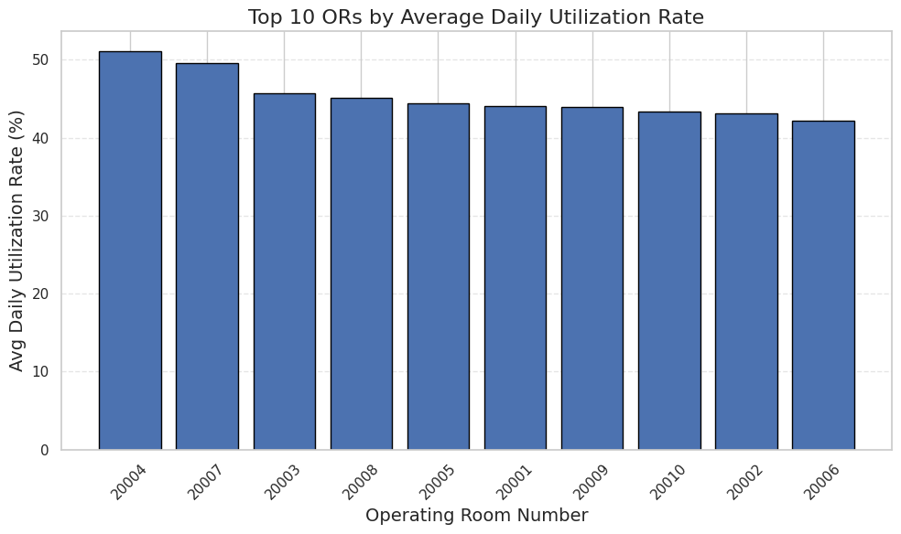

Figure 14. ranks the ten busiest operating rooms (ORs) at Assuta Ramat HaHayal by their average daily utilization rate over the entire study period. This chart highlights which rooms consistently operate at higher capacity and may be considered high-performing or high-demand environments within the surgical wing.

At the top of the list stands OR 20004, with an average daily utilization rate of just above 50%, making it the most intensively used room across all time frames. This room likely serves as a key site for high-throughput surgical specialties or is assigned to surgeons with consistently high block utilization. Close behind is OR 20007, with a mean utilization of approximately 49%, reinforcing its role as another central hub of activity.

The next group of rooms—including 20003, 20008, 20005, and 20001—cluster around 44–46% utilization, representing stable, mid-to-high activity environments. These rooms may serve as flexible scheduling spaces, balancing both elective and urgent cases throughout the year. Notably, the final rooms in the top ten—20009, 20010, 20002, and 20006—still maintain respectable average utilization levels around 42–43%, underscoring their sustained operational role despite slightly lower throughput.

What emerges from this ranking is a meaningful variability in performance between rooms, with a spread of approximately 8–9 percentage points separating the top and bottom of the list. While all ten ORs operate with significant activity, this gradient points to potential differences in scheduling efficiency, case complexity, surgeon assignment, or room availability due to maintenance or resource constraints.

For planning purposes, high-utilization rooms such as 20004 and 20007 warrant particular attention when considering future capacity expansion, maintenance timing, or elective block prioritization. Conversely, rooms with lower average usage—while still active—may represent opportunities for load balancing, short-case clustering, or piloting dynamic scheduling models aimed at improving hospital-wide utilization.

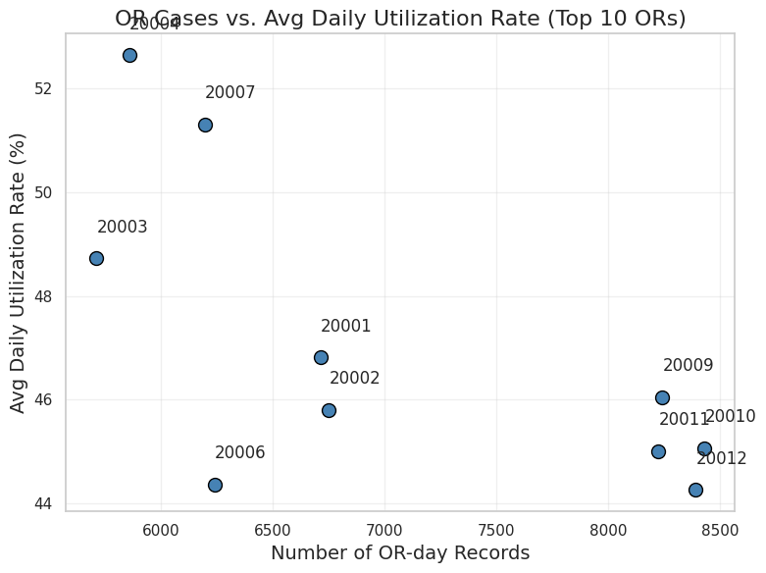

Figure 15. explores the relationship between number of recorded OR-days and average daily utilization rate for the top ten operating rooms (ORs) in the dataset. Each point represents a single OR, with its horizontal position reflecting how many days it was operationally active and its vertical position representing how intensively it was used on average during those days.

A clear pattern emerges: rooms with fewer recorded days often show higher average utilization, while rooms with more recorded days tend to cluster around slightly lower utilization rates. This is especially evident with OR 20004, which despite being used on relatively fewer days (under 6,000), achieves the highest average utilization rate at ~52.5%. Similarly, OR 20007 also demonstrates high efficiency (~51.3%) with a moderate number of OR-days (~6,200). These rooms likely represent high-throughput blocks assigned to specific specialties or surgeons with dense elective schedules and minimal downtime.

On the opposite end, ORs 20009, 20010, 20011, and 20012 each show a higher number of recorded days (8,000–8,500) but lower utilization rates (~44–46%). These rooms may serve broader purposes, such as more diverse scheduling with downtime between procedures, or be subject to more frequent partial-day use, flexible assignments, or emergency case absorption. This suggests that availability does not directly correlate with intensity of use—some rooms operate nearly every day but at lower capacity, while others function fewer days but more intensively.

Interestingly, OR 20003 stands out as a mid-point room: it has relatively fewer days (~5,800), but still achieves nearly 49% utilization, reinforcing its status as a balanced and efficient room. OR 20006, by contrast, has slightly lower utilization (~44.3%) despite moderate usage, possibly reflecting scheduling inefficiencies or equipment-related limitations.

This scatterplot reinforces a key operational insight: utilization efficiency and room availability are not inherently coupled. For planning and optimization, it may be worthwhile to investigate whether some high-availability, low-utilization rooms could be reconfigured or reallocated, and whether high-utilization rooms with limited exposure can be leveraged more regularly without compromising performance. Such findings could inform future decisions around block reallocation, maintenance timing, or even redesign of scheduling policies.

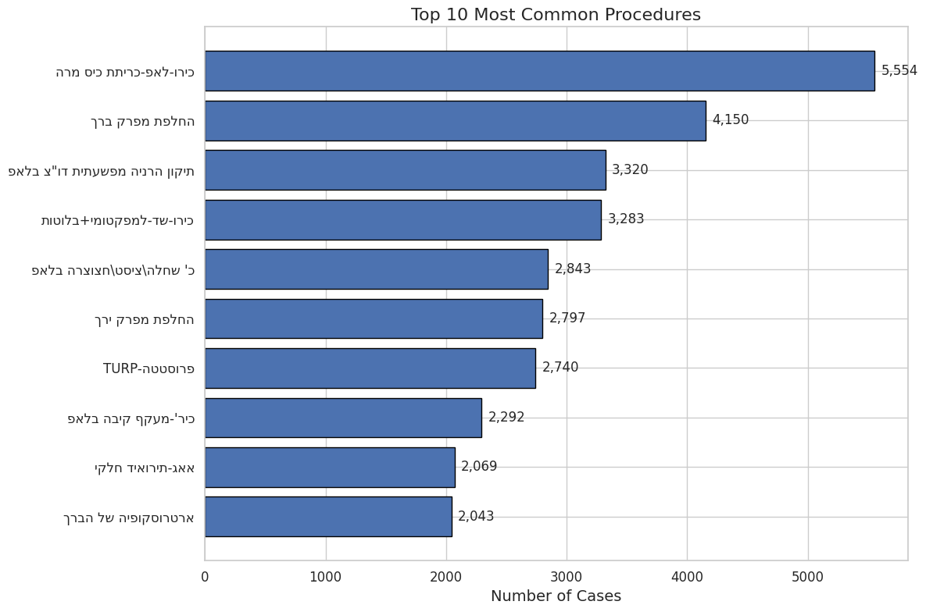

Figure 16. presents the ten most frequently performed surgical procedures at Assuta Ramat HaHayal, ranked by the total number of recorded cases. This breakdown provides a focused view of the hospital’s procedural landscape, offering insight into the dominant specialties and case types that shape operating room (OR) demand.

At the top of the list is laparoscopic cholecystectomy (כרו-לאפ-כריתת כיס מרה), with 5,554 cases, indicating its status as the most routine and high-volume surgery. This is consistent with national and international data, as gallbladder removal remains a common elective procedure typically performed in a minimally invasive manner with relatively short OR times and recovery durations.

In second place, total knee replacement (החלפת מפרק ברך) registers 4,150 cases, underscoring the high burden of orthopedic degeneration and the significant role of joint replacement in surgical planning and bed occupancy. Orthopedics continues to be a major driver of OR time, especially for longer and more resource-intensive procedures.

The next tier includes spinal decompression and stabilization (תיקון הרניה משפעתית דוו"צ בלאפ) and mastectomy with lymph node dissection (כרת-שד-למפקטומי+בלוטות), with 3,320 and 3,283 cases, respectively. These reflect two other high-impact domains: spinal surgery (often associated with extended surgical duration and recovery) and breast oncology, which contributes not only to surgical volume but also to post-operative care and multidisciplinary coordination.

Several other urological and general surgical procedures round out the list, including urological resections (TURP – פרוסטטה), bladder tumor excision, inguinal hernia repairs, and laparoscopic nephrectomies. Of particular note is hip replacement surgery (החלפת מפרק ירך), with 2,797 cases, again reinforcing the significance of orthopedic load on OR throughput.

While some procedures (like TURP or hernia repairs) are relatively brief and predictable, others (e.g., complex oncology or spine cases) may introduce more variability into scheduling and length-of-stay planning. This diverse procedure mix has direct implications for block allocation, staffing by specialty, and the design of predictive models for OR time and resource needs.

In sum, this distribution shows that while a small set of procedure types dominate numerically, they span a wide range of specialties and complexity levels. Any optimization efforts—whether around scheduling, duration prediction, or bed management—must therefore accommodate both high-volume, low-variability cases and lower-frequency, high-variability procedures within the same operational framework.

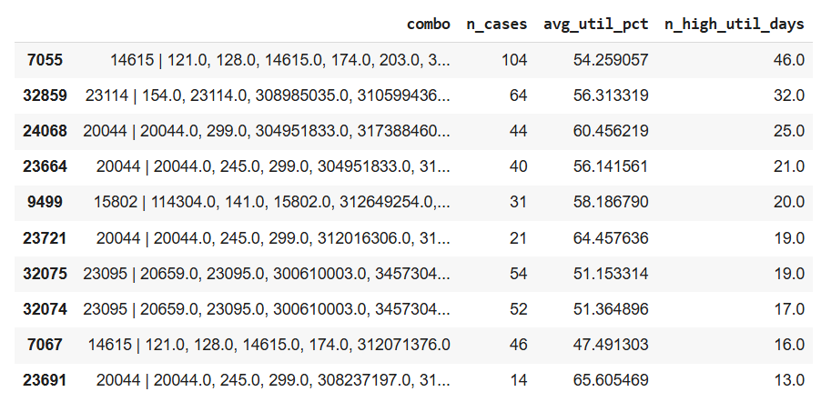

Table 1 summarizes the top-performing surgical case combinations ("combos") based on their contribution to operating room (OR) utilization efficiency. Each row represents a recurring sequence or bundle of procedures grouped under a shared combo ID. For each combination, the table reports: the total number of times it occurred (n_cases), its average daily utilization rate (avg_util_pct), and how many of those days were considered high-utilization days (n_high_util_days)—defined as days where OR utilization exceeded a pre-set operational threshold.

Several patterns emerge from the data. Notably, Combo 23721, despite having only 21 occurrences, achieved the highest average utilization of all entries: 64.5%, with 19 of those days qualifying as high-utilization. This suggests that this specific set of procedures forms an exceptionally efficient operational unit, likely due to optimal alignment of procedure durations, turnover times, and overall flow.

Similarly, Combo 23691, with only 14 recorded instances, achieved an even higher average utilization of 65.6%, albeit with fewer high-utilization days (13). These two combinations, while less frequent, demonstrate a clear capacity for concentrated throughput and may serve as models for efficient block planning.

By contrast, Combo 24068 was executed 44 times, with an average utilization of 60.5% and 25 high-utilization days, suggesting that this combination offers both consistency and frequency in generating efficient OR usage. This makes it a particularly promising candidate for replication across future scheduling templates.

On the higher-volume side, Combo 7055 occurred 104 times, yielding a respectable average utilization of 54.3%, with 46 days of high utilization. Though not as extreme as the peak performers, this combination stands out due to its balance of frequency and reliability, and may be considered a “workhorse” configuration for everyday scheduling.

At the lower end of the spectrum, Combo 7067, while relatively common (46 cases), demonstrated the lowest average utilization in the table (47.5%) and only 16 high-utilization days. This suggests either inefficiencies in the composition of the bundle (e.g., mismatched procedure lengths or downtime gaps) or variability in case execution.

In summary, this analysis reveals that certain combinations—especially those with medium frequency and high utilization—can act as anchor patterns for future block scheduling. Conversely, low-efficiency combos may benefit from reassessment or reconfiguration. The ability to identify and track these patterns lays the groundwork for data-driven optimization of surgical scheduling, aiming to increase OR efficiency not just on average, but through consistent, replicable case bundles.

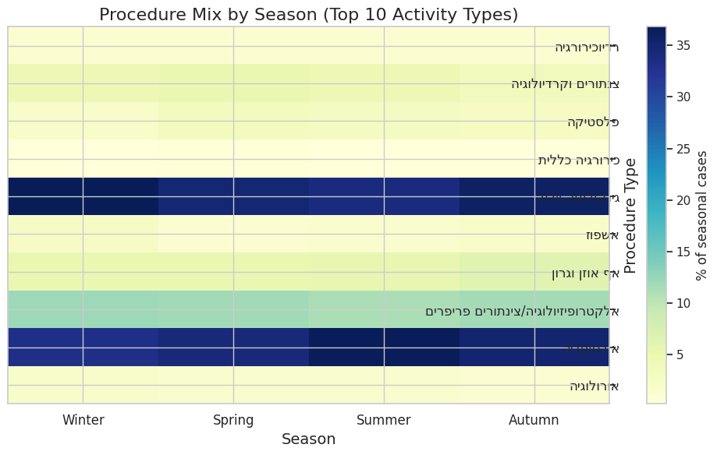

Figure 17 presents the seasonal distribution of the ten most common procedure types, expressed as a percentage of total surgical cases per season. This heatmap highlights how the procedural mix fluctuates throughout the year, revealing both stable and dynamic trends across specialties.

Two procedure types dominate consistently across all seasons: גינקולוגיה וילוד (Gynecology & Obstetrics) and כירורגיה כללית (General Surgery). Together, they account for a substantial portion of the seasonal case volume, each contributing over 30% in several months. Interestingly, gynecology & obstetrics shows a peak in summer and autumn, suggesting a possible alignment with planned admissions or scheduling preferences that avoid winter months. In contrast, general surgery maintains a more balanced presence but dips slightly in autumn.

אורולוגיה (Urology) also maintains a steady footprint across seasons, averaging around 8–9% of total procedures. Meanwhile, אורתופדיה (Orthopedics) demonstrates clear seasonal variability—reaching a relative peak in summer, possibly due to school holidays or elective procedure planning during patient leave periods.

Another dynamic specialty is א.א.ג (אף אוזן גרון) (ENT), which fluctuates moderately but sees slightly higher representation in spring and autumn, aligning with trends seen in pediatric or seasonal respiratory-related procedures.

By contrast, אלקטרופיזיולוגיה/צינתורים פריפריים (Electrophysiology and peripheral catheterizations) remains highly stable across all seasons, consistently contributing ~10% of cases. This indicates that these time-sensitive, protocol-driven procedures are less subject to seasonal scheduling biases.

Lesser-represented specialties such as פלסטיקה (Plastic surgery), צנתורים וקרדיולוגיה (Cardiology), and כירורגיה רדיולוגית (Interventional radiology) account for smaller shares overall (typically <5%), but their proportions remain stable—suggesting they are scheduled regularly in small volumes rather than in seasonal bursts.

From an operational perspective, this analysis emphasizes the importance of recognizing seasonally dominant specialties when planning elective blocks. For instance, higher loads of gynecological and orthopedic cases in summer and autumn may justify reallocating OR resources toward these services during those months. Similarly, the stability of catheter-based procedures supports fixed scheduling models, while specialties like ENT and general surgery might benefit from flexible slot allocation that reflects their seasonal variability.

In summary, the seasonal mix of procedures is not uniform. A data-driven understanding of these fluctuations can inform capacity planning, staffing alignment, and dynamic scheduling policies, ultimately supporting a better match between OR resources and expected demand across departments.

### **Summary of Key Findings and Operational Insights**

The analysis of operating room (OR) utilization at Assuta Ramat HaHayal revealed several consistent patterns and data-driven insights that can support more efficient scheduling, capacity planning, and resource management.

First, a **clear seasonal cycle** emerged across all dimensions—daily utilization, monthly averages, procedure mix, and room usage. **Utilization peaks consistently in winter and spring**, particularly in February–March, with average rates exceeding 45%, while **autumn (September–November) shows the lowest utilization**, dipping to ~37%. These seasonal trends were statistically robust and confirmed across both aggregated averages and decomposed time-series components. Based on this, it is strongly recommended to **prioritize full elective blocks and increased staffing in late winter and spring**, and to **allocate maintenance and staff leave windows during autumn** to minimize operational disruption.

Second, at the **room level**, several ORs—most notably **20004 and 20007**—demonstrated consistently **higher average utilization** (above 50%), suggesting they are both heavily and efficiently used. These rooms may be ideal candidates for load balancing or replication in scheduling policies. Conversely, several rooms with high availability but moderate utilization (e.g., 20010, 20012) may benefit from strategic reassignment or targeted optimization. Importantly, **room availability does not correlate directly with utilization intensity**, highlighting the need to evaluate room performance based on both frequency and efficiency.

Third, analysis of **procedure types and seasonal mix** revealed that some specialties, like **gynecology, orthopedics, and ENT**, exhibit strong seasonal variability—peaking in summer or autumn—while others, such as **electrophysiology and catheter-based interventions**, remain stable throughout the year. This reinforces the need for **adaptive scheduling models** that assign dynamic block configurations to seasonal specialties while preserving fixed slots for stable, high-frequency procedures.

In addition, the breakdown of **top-performing case combinations (combos)** revealed that some procedure bundles consistently achieve **high utilization rates (>60%)** and a high number of “efficient days,” even when they are relatively rare. These combos may serve as **building blocks for optimized daily schedules**, while common yet inefficient combinations (e.g., Combo 7067) could be revised or restructured. Identifying and replicating high-efficiency combinations offers a clear path toward improving operational consistency.

Finally, day-to-day utilization patterns showed **large variability and limited autocorrelation**, meaning that aside from seasonality and structural scheduling, many fluctuations are random. This underscores the importance of having **real-time operational flexibility**—such as same-day add-on capacity, cancellation management, and adaptive staffing—to complement long-term planning.

**In summary**, the most important findings can be distilled into three strategic recommendations:

1. **Plan by season**: Concentrate elective volume in winter and spring; allocate maintenance and staff leave in autumn.
2. **Optimize by room and combo**: Expand the use of high-performing ORs and procedure bundles; investigate underperforming patterns.
3. **Balance long-term design with short-term agility**: Combine data-driven scheduling templates with real-time responsiveness.

These insights form the foundation for designing a more efficient, resilient, and data-informed OR management system.